Tau Talk

January 2013
Volume 37 Issue V

Newsletter of Tau Chapter #19 Limestone-Freestone Counties, Area VIII
Alpha State Texas
The Delta Kappa Gamma Society International

Mission Statement of Delta Kappa Gamma The Delta Kappa Gamma Society International promotes professional and personal growth of women educators and excellence in education.

********************************************************************************************

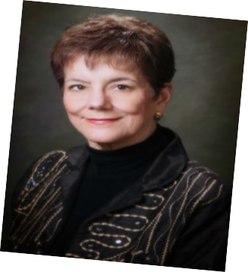President’s Message:
I hope that each of you is staying warm and healthy
during these winter months, and I have to equally hope that our Texas legislators are handling
our state’s business wisely. The legislature is in session and the
TSO Legislative Update for January
provided several items of interest to watch. Funding is always an issue, but add to that a concern for TRS for both active and retired educators, and accountability issues.
DKG’s Legislative Chair, Suzanne Bathe, has encouraged Texas members to stay in contact with their legislators throughout the session.
To locate your representative and senator, visit http://www.fyi.legis.state.tx.us and enter your address. Their names and contact information can be found at this site.
Congress is back in session in Washington D.C. You can find information on how your congressman voted on key bills by visiting http://projects.washingtonpost.com/
congress/111bills. Contact your congressman through
http://www,house.gov/ and your senator through http://senate.gov/. The Congressional Switchboard’s Number is toll free, 1-800-327-8670, and the number for the White House is 1-202-456-1111.
Let Your Voice Be Heard! Virginia Riddle, President Tau Chapter

Working the Plan:
Alicia Smith, Wynona Lipsett, and Virginia Riddle represented Tau Chapter at the DKG Chapter Council
Meeting held at Luby’s Cafeteria in Waco on January 20, 2013. Plans are now underway in earnest for the May 4, 2013 Founders Day Luncheon that will be held
at 11:00 a.m. at Ridgewood Country Club in Waco. Tau Chapter is responsible for the ceremonies, music, and
Publicity this year. Wynona is planning a very special
ceremony honoring the founders. This was a wonderful luncheon to attend and a great opportunity to network with mem- bers of the Waco area chapters. Save the date now, and look for further updates as spring approaches.
*********************************************

Upcoming Deadlines:
March 1—Applications are due for Alpha State
Scholarships. Obtain guidelines and applications from the State Scholarships page of the Alpha State Website. (www.alphastatetexas.org)
March 1—State Convention Workshop proposals are due. Proposal applications are on the Deadlines and Forms page of the Alpha
State Website.
(www.alphastatetexas.org)

State Convention Opportunities:
In a recent edition of A “Capital” Convention I read where exciting plans for the State Convention, to be held
on June 20-22, 2013, at the Renaissance Hotel in Austin, Texas were underway. Everyone is invited to “Explore the Possibilities” and let your vision light the
way where you can celebrate, collaborate and communi- cate with your Society friends and sisters.
The presentation of chapter presidents will take on a
new look with a program to be entitled “Belles and a Broadway Beau” which will feature David Gaschen, a native of Lubbock, in concert.
“Crafting Lives of Significance” will be presented by Anne Barab in the Leadership management Advanced Seminar. Barab’s program teaches people how to craft resilient, robust, juicy lives of significance. Her core message helps people learn how to balance work, home and relationships; thrive in times of change; put stess in the past tense and think like a leader.
Dr. Beverly Helms, current President for DKG International, will be the speaker for the Birthday Celebration Luncheon. She is known for her caring and compassionate nature and is a delightful speaker as well as a dynamic leader. She is a true asset to our Society.
Tau Members: Let Virginia Riddle know ASAP if you are planning to attend the state convention. We have a room reserved that will accommodate four of us and possibly five with a roll away. Space is first come, first served!
Looking for Photographers!!! Carol McMillan, State Editor/Photographer of the Lone Star News, is asking for member volunteers to help take photos at the
state convention. If you are planning to attend and have a camera, please send your name and contact information to her ASAP. Carol’s email is news.lonestar@gmail.com. This would be a fun way to participate and, if you are an aspiring professional pho- tographer, would give you needed publication clips.
********************************************

Dates to Remember:
*NO MEETING IN FEBRUARY
*Monday, March 4, 2013 Fairfield Public Library
350 W. Main, Fairfield
Time: 4:30 p.m. Refreshments 5:00 p.m. Meeting
Program: “My Purse is My Life”
Presenter: Alicia Smith Inspirational: Walta Evans
Hostesses: Lori Logenbaugh & Glenda Nelson
*Saturday, April 6, 2013 Home of Virginia Riddle
Lake Mexia
Time: 10:00 a.m. for Brunch
Program: Orphanage visited in India
Presenter: Our own Golden Rose, Martha Kirgan
Inspirational: Patty Manley
Hostesses: Ask Virginia what to bring

FYI:
Helping Websites:

TAU Chapter: http://alstau.weebly.com State Organization: www.alphastatetexas.org International Organization: www.dkg.org
*********************************************

Welcome to Tau’s Newest Members:

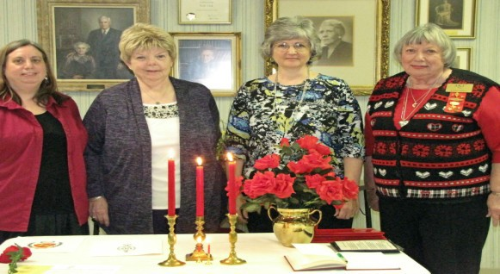

Ronda Brewer, Cheryl Karkheck, Vickie McDougal, Wynona Lipsett

During the January meeting, Vickie McDougal and Cheryl Karkheck were initiated as Tau Chapter’s newest members. We also approved Judy Ann Bell Mulhol- land’s application. She will be initiated during our April meeting which will be held at Virginia Riddle’s home at Lake Mexia on April 6, 2013 at 10:00 a.m.
*********************************************

Chapter Officers:
President: Virginia Riddle
1st Vice President: Anna Pat Alpert 2nd Vice President: Goldia Liles Recording Secretary: Margaret Day Corresponding Secretary: Patty Manley Treasurer: Martha Kirgan Parliamentarian: Alicia Smith *Newsletter Editor: Goldia Liles Email: goldial@sbcglobal.net

